**W2 -** HOMEWORK

*Functions & Modular Design (Part 1)*

## *At the end of this practice, you should be able to…*

* Decompose a **larger problem into smaller**, reusable functions.
* **Define and implement functions** in C with appropriate **parameters** and **return** types.
* Use **function calls** effectively Use **debugging** **techniques** to check for errors.

## *How do we structure exercises?*

We organize each practice into 3 parts:

|  |  |
| --- | --- |
| ANALYSE | **Understand** existing codes, find the **bugs** or **complete** missing gaps |
| MANIPULATE | Ensure you can **apply the theory** with some basic challenges |
| CREATE | **Express your creativity** with more complex challenges |

*How to submit?*

* Submit this document in **UMS (LMS)**
* File format: **Fullname_W2_HW.pdf**
  + *Example: Chan_Dara_W2_HW.pdf*
* Deadline: 03rd May 2025, 11:59 pm

## *Are you lost?*

You can read the following documentation to be ready for this practice

<https://pseudocode.deepjain.com/guides/functions/>

<https://www.w3schools.com/c/c_functions.php>

CREATE

**PROBLEM (Knight & Monster Battle)**

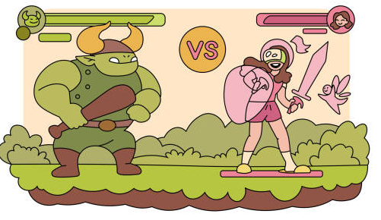

Write a C program simulating a **fight between a knight and a monster**.

* Both knight and monster **start** with **20 life points**.
* The game continues in rounds **until one of them has 0 or less life**.

You are building a **turn-based battle game**. Each round contains:

1. Knight chooses an action:  
   a. **Attack**  
   b. **Heal**  
   c. **Special attack** (available every 3 turns only!)
2. Monster always attacks after knight.

At the end of each round:

* Print what happened.
* Show current life of knight and monster.
* Ask knight for next move (loop).

The game ends when **either the knight or the monster's life drops to 0 or less**.

*Functions You Need to Implement*

To follow a top-down design approach, you need to define the bellow functions to run the game:

|  |  |  |
| --- | --- | --- |
| Function Name | Purpose | Return Type |
| int attack(); | Knight's regular attack  *(returns a random number between 5–12)* | int |
| int heal(); | Knight's healing  *(returns a random number between 8–15)* | int |
| int specialAttack(); | Special attack  *(returns a random number between 8–25)*  *Note*: *only usable every 3rd round.* | int |
| int monsterAttack(); | Monster’s counterattack  *(returns a random number between 8–12)* | int |
| void printStatus(; | Prints current lives of knight and monster | void |
| void printRoundLog(); | Describes what happened during the round | void |

*How to generate a random number in C?*

You can use the library time.h:

#include <stdlib.h>

#include <time.h>

// return a random number betwee min and max

int **getRandomInRange**(int min, int max) {

return min + rand() % (max - min + 1);

}

Note: you need to call **srand(time(NULL));** once in main() to seed the random number generator.

int main() {

srand(time(NULL)); // Seed random number generator

…

}

*Start Code*

// Your functions…

// The main

int main() {

srand(time(NULL)); // Seed random number generator

int knightLife = 20; // The knight lives

int monsterLife = 20; // The monster lives

int turn = 1; // The round index

while (knightLife > 0 && monsterLife > 0) {

// Your main code

}

return 0;

}

*Scenario example (console results)*

--- Round 1 ---

Choose your action: (A)ttack, (H)eal, (S)pecial Attack

> A

You attacked the monster and dealt 7 damage.

The monster attacked and dealt 6 damage.

Knight HP: 14

Monster HP: 13

------------------------------

--- Round 2 ---

Choose your action: (A)ttack, (H)eal, (S)pecial Attack

> H

You healed yourself for 10 points.

The monster attacked and dealt 5 damage.

Knight HP: 19

Monster HP: 13

------------------------------

--- Round 3 ---

Choose your action: (A)ttack, (H)eal, (S)pecial Attack

> S

You used SPECIAL ATTACK and dealt 21 damage!

The monster attacked and dealt 8 damage.

Knight HP: 11

Monster HP: 0

------------------------------

🎉 Victory! You defeated the monster!